DIGITAL MARKETING

Assignment 1- Creating a blog. Customizing the theme design and

Posting a new article with 500 words

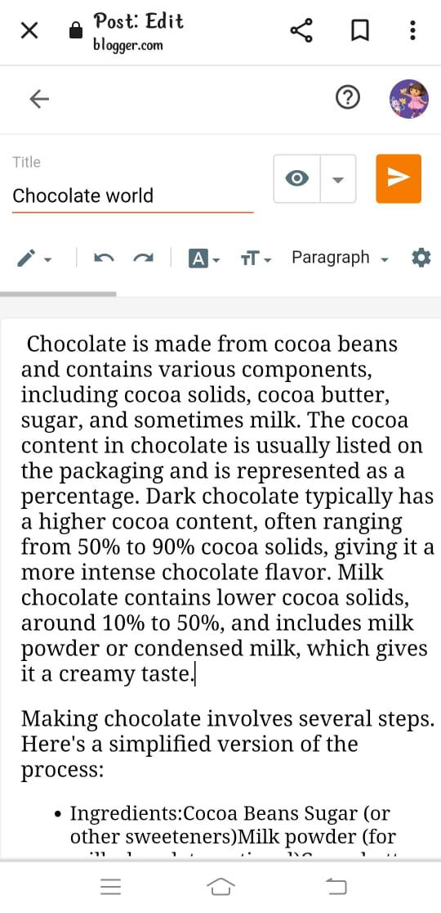

Blogger post link:

<https://www.blogger.com/blog/post/edit/5678674003426834245/8724874921810432428>

Passage:

CHOCOLATE WORLD

“Celebrating the world’s favourite treat”

Chocolate is made from cocoa beans and contains various components, including cocoa solids, cocoa butter, sugar, and sometimes milk. The cocoa content in chocolate is usually listed on the packaging and is represented as a percentage. Dark chocolate typically has a higher cocoa content, often ranging from 50% to 90% cocoa solids, giving it a more intense chocolate flavour. Milk chocolate contains lower cocoa solids, around 10% to 50%, and includes milk powder or condensed milk, which gives it a creamy taste.

Making chocolate involves several steps. Here's a simplified version of the process:

Ingredients: Cocoa Beans Sugar (or other sweeteners) Milk powder (for milk chocolate, optional) Cocoa butter (extracted from the beans) Flavourings such as vanilla (optional)

Steps:

Harvesting and Fermentation: Cocoa beans are harvested from cocoa pods and left to ferment. This process develops the beans' flavour.

Drying: After fermentation, the beans are dried under the sun.

Roasting: Dried beans are roasted to bring out the chocolate flavour. The shells of the beans become brittle and can be removed, leaving the nibs.

Cracking and Winnowing: The roasted beans are cracked open, and the nibs are separated from the shells.

Grinding: Nibs are ground into a liquid known as cocoa mass or cocoa liquor. This contains both cocoa solids and cocoa butter.

Conching: The chocolate mass is refined further in a conche, which smoothens the texture and enhances the flavour.

Tempering: The chocolate is tempered by carefully heating and cooling it, ensuring smooth texture and glossy appearance when it sets.

Molding: Finally, the tempered chocolate is poured into molds and allowed to cool and harden.

Types of Chocolate:

Dark Chocolate: Contains cocoa solids and cocoa butter without milk solids. It has a rich, intense flavour. Milk Chocolate: Contains cocoa solids, cocoa butter, milk solids, and sugar. It's sweeter and creamier due to the addition of milk.

White Chocolate: Doesn’t contain cocoa solids but is made from cocoa butter, sugar, and milk solids. It lacks the characteristic chocolate colour but has a sweet, creamy taste.

Ruby Chocolate: Made from specially processed ruby cocoa beans. It has a pinkish-red hue and a unique berry-like flavour.

Bittersweet and Semisweet Chocolate: These are terms used in recipes and often interchangeable with dark chocolate, but they may have varying percentages of cocoa solids and sugar.

Each type of chocolate has its unique characteristics and uses in cooking and baking.